**Kaisaka Web Solution**

Kaisaka Developer’s Feature and Technical Map

**Overview**

This document provides a comprehensive mapping of features to user stories for the Kaisaka system, organized by sprint and technical implementation layers.

**Feature Map**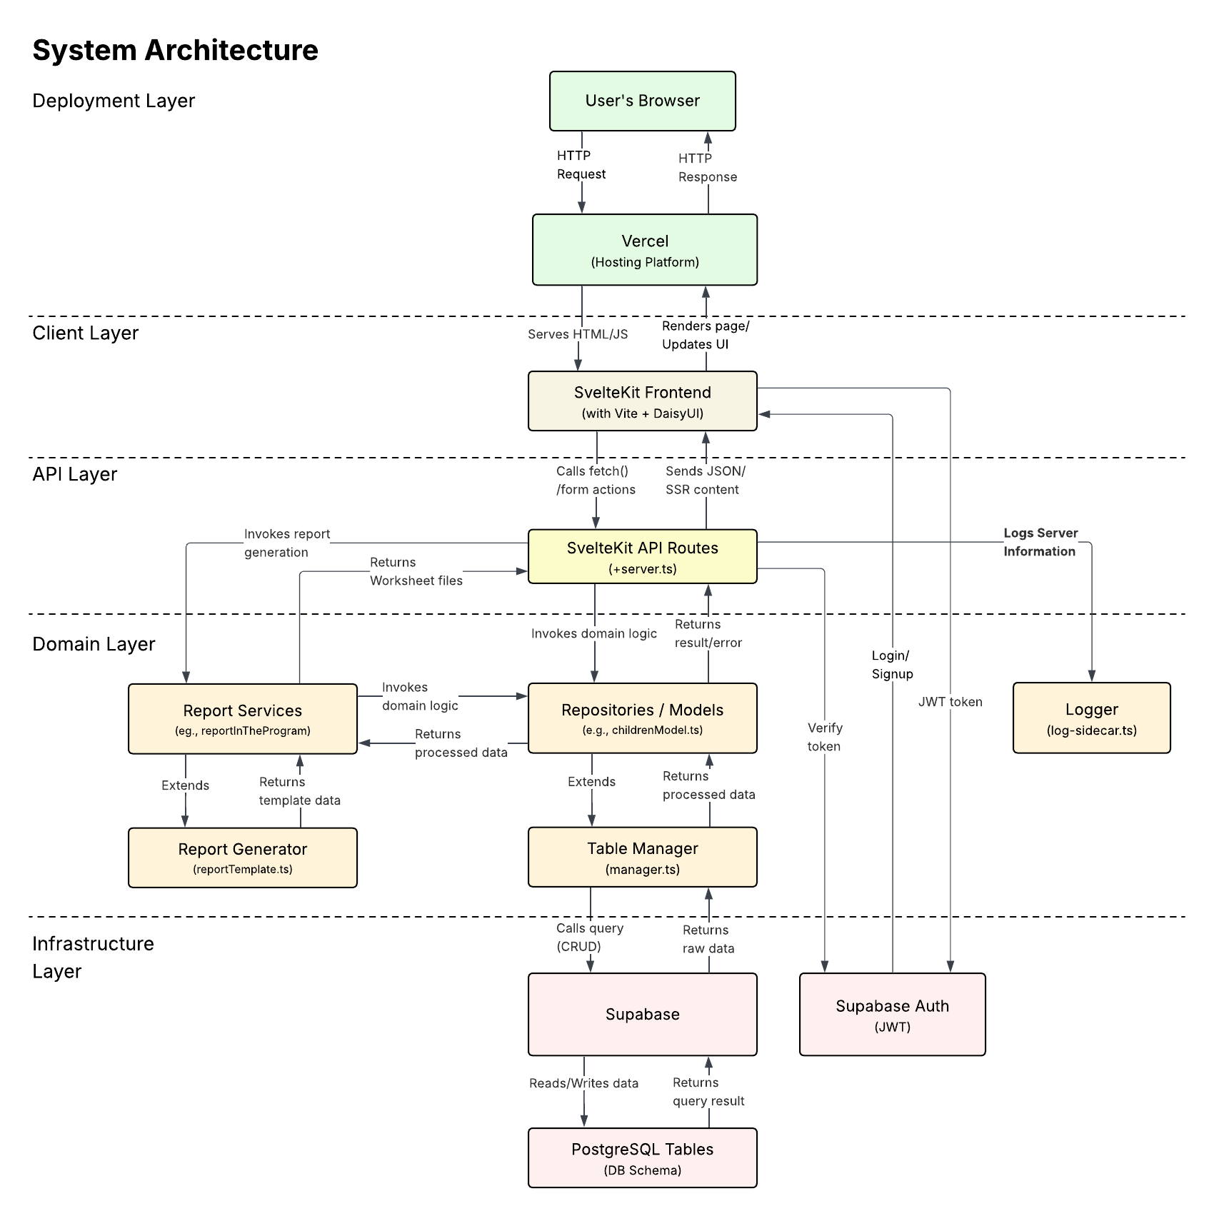

Figure 1: Feature Map Overview

The system is built around a **Varied Data Retrieval System** using the Repository Design Pattern, supporting comprehensive management of children, caregivers, families, and organizational reporting.

The organization naturally has a lot of varied information that needs to be accessed, so various registration and services require some specific information tied to specific objects such as Children and Caregivers. Thus, the infrastructure ought to be built in mind to support this wide variety of information. Therefore, this solution is built on a modified version of a design pattern principle named the Repository Design Pattern.

Simply put, the Repository Design Pattern separates the logic necessary to write and read information to three groups, namely:

1. the Database Repository class, handling the Supabase Database logic;
2. the Concrete Repository instances, handling the Business logic required to handle the object; and
3. the API handlers / Controller interfaces, handling how clients and users interact with the objects

# **Entity Relationship Diagram**

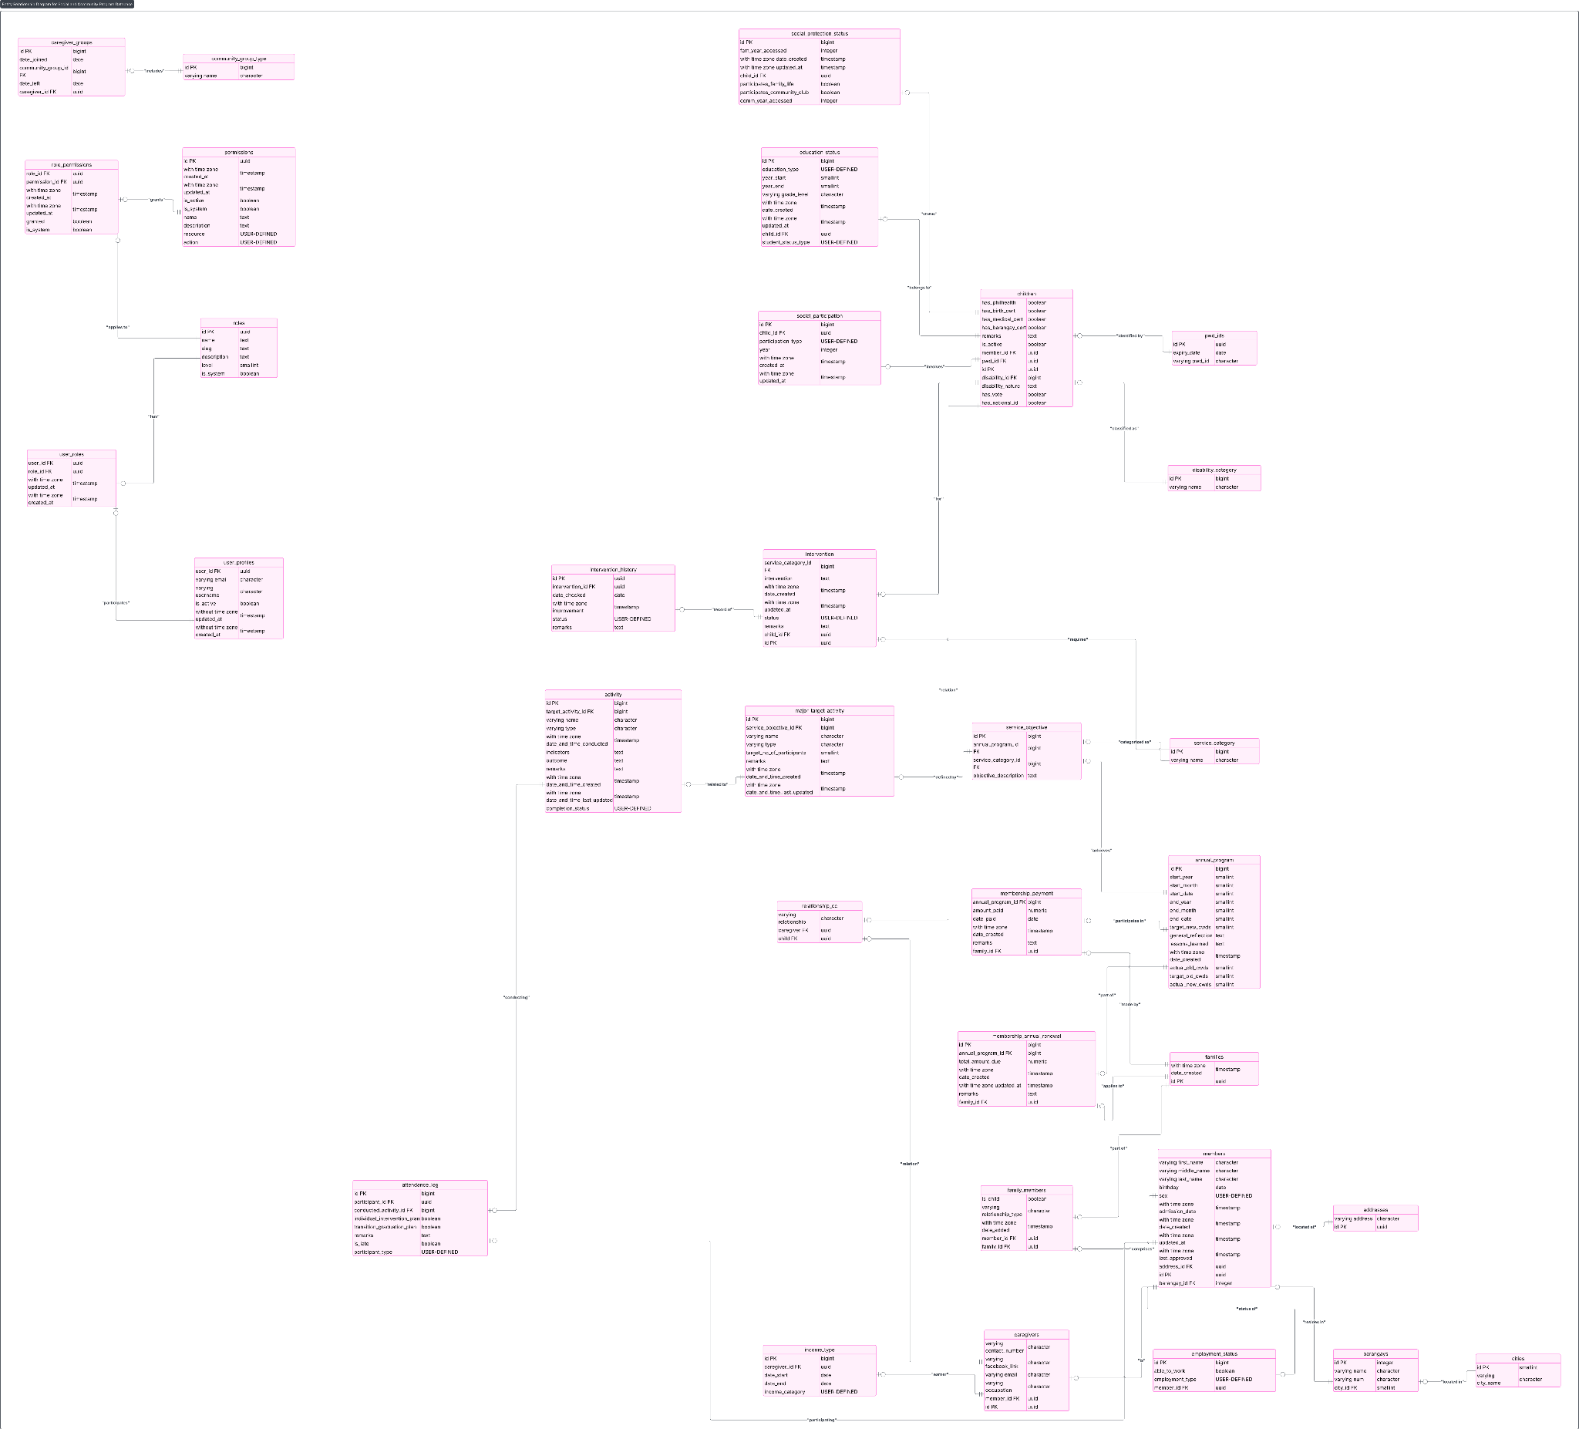

Figure 2: Entity Relationship Diagram

The system manages relationships between:

* **Children (CYWDs)** - Core beneficiary records
* **Caregivers** - Adult family members and guardians
* **Families** - Grouped relationships between children and caregivers
* **Interventions** - Services and support provided
* **Activities** - Events and programs
* **Reports** - Annual and quarterly organizational reports
* **Attendance** - Participation tracking
* **Payments** - Membership and service fees

# **Features List**

**Core Data Management System**

### **Children Management (CYWD Management)**

**User Stories Addressed:**  1.10, 1.17, 1.20, 2.7, 2.14, 2.18, 2.19, 4.1-4.12

Features:

* CRUD Operations: Create, read, update, and delete child records
* Certificates: Manage birth certificates and other official documents
* Disability Info: Track disability status and related details (including Down Syndrome)
* Activity Status: Monitor participation in activities and interventions
* Age and Gender Categorization: Support for demographic analysis
* Education Status Tracking: Enrollment, dropout, and completion monitoring
* Intervention Plan Management: Track children with intervention plans
* Transition/Graduation Plans: Monitor progress toward independence
* Improvement Recording: Document and track child development
* Logging: Actions on children logged for audit and traceability

### **Caregivers Management**

**User Stories Addressed:**  1.6, 1.11, 1.18, 2.3, 2.8, 2.15, 4.8, 4.9

Features:

* CRUD Operations: Manage caregiver profiles and relationships
* Contact Info: Store phone numbers, addresses, and emails
* Occupation & Income: Track employment status and income levels
* Income-Generating Activities: Categorize by activity type
* Community Group Participation: Track involvement in community organizations
* Self-Registration: Allow caregivers to register their own families
* Logging: Caregiver changes and interactions logged

### **Families Management**

**User Stories Addressed:**  1.12, 1.19, 1.20, 2.9, 2.16, 2.20

Features:

* CRUD Operations: Create, update, and delete family units
* Family Composition: Link children and caregivers to families
* Dynamic Family Search: Search and link to existing families during registration
* Family Relationship Mapping: Clear visualization of family structures
* Reports Generation: Generate family composition and status reports

**Activity and Event Management**

### **Activities Tracking**

**User Stories Addressed:** 1.14, 1.15, 2.11, 2.12, 2.19

Features:

* Target Activities: Plan and categorize upcoming events
* Completed Activities: Track finished events with timestamps
* Activity-Participant Linking: Associate activities with children, families, or events
* Progress Monitoring: Track planned vs. completed activities
* Date and Priority Organization: Structured activity scheduling

### 

### **Attendance Management**

**User Stories Addressed:** 1.16, 2.13, 2.19

Features:

* Event Attendance Tracking: Record attendance for events and activities
* Participant Type Distinction: Differentiate between children, caregivers, and others
* Status Indicators: Visual representation of attendance status
* Remarks: Add notes on attendance or absences
* Reports Generation: Attendance summaries and participation rates

**Financial Management**

### **Membership Payments**

**User Stories Addressed:** 2.20

Features:

* Payment Records: Track membership payments, dates, and amounts
* Remarks: Add notes or remarks to payment entries
* Reports Generation: Summarize payment history and outstanding dues

**Service Delivery**

### **Interventions Management**

**User Stories Addressed:** 2.17, 2.18, 2.19

Features:

* CRUD Operations: Manage interventions for children and families
* Status Updates: Track progress and completion of interventions
* Intervention Plans: Create and manage structured support plans
* Remarks: Add notes on intervention outcomes
* Logging: Intervention actions logged for review

### **Intervention History**

**User Stories Addressed:** 2.17, 2.18, 2.19

Features:

* Tracking: Maintain a history of interventions per child/family
* Improvement Status: Record progress and improvements over time
* Reports Generation: Generate intervention effectiveness reports

**Verification and Compliance**

### **Pending Verifications**

**User Stories Addressed:** 1.13, 2.10

Features:

* Document Status Tracking: Monitor verification status of official documents
* Real-time Updates: Fetch current verification statuses from server
* Filtering: Filter and search pending verifications
* Action Tracking: Monitor what actions are needed for completion

**Educational Tracking**

### **Education Status Management**

**User Stories Addressed:**  4.4, 4.5

Features:

* Enrollment Tracking: Monitor school enrollment status
* Educational Transitions: Track new enrollments, dropouts, and completions
* Education Type Categorization: Support different education levels and types
* Student Status Monitoring: Track academic progress and changes
* Age and Gender Analysis: Demographic breakdown of educational data
* Reports Generation: Educational attainment and dropout statistics

**Social Protection and Employment**

### **Social Protection Status**

**User Stories Addressed:**  4.6, 4.7

Features:

* Program Participation: Track participation in social protection programs
* Community Engagement: Monitor involvement in family life and community activities
* Access Tracking: Monitor previous and current year access to social protection
* Reports Generation: Social protection participation reports

### **Labor Market Access**

**User Stories Addressed:**  4.10, 4.11

Features:

* Employment Tracking: Monitor labor market access by gender and employment type
* Disability-Specific Tracking: Separate tracking for CYWDs with and without Down Syndrome
* Work Capability Assessment: Track CYWDs unable to work by gender
* Historical Comparison: Compare previous and current year employment data
* Reports Generation: Employment outcome and barrier analysis

**Comprehensive Reporting System**

### **Annual and Quarterly Reports**

**User Stories Addressed:**  3.1-3.7, 4.1-4.12

Features:

* **Report Period Management:**
  + View quarterly/annual reports list with year, target, and actual CYWD counts
  + Search functionality for specific report periods
  + Add new report periods
  + Edit existing report details
* **Auto-Generated Tables:**
  + Target vs. Actual CYWD counts (old and new beneficiaries)
  + Disability-specific counts (Down Syndrome tracking)
  + Intervention statistics by age group and gender
  + Educational access and transition data
  + Social protection participation metrics
  + Caregiver participation by income and community involvement
  + Labor market access by employment type and gender
* **Export Functionality:** 
  + Excel export with pre-formatted templates
  + Auto-populated cells for calculated data
  + Blank cells for manual editing
  + CYWD reference list export with identification numbers
* **Report Categories:** 
  + Service delivery and intervention effectiveness
  + Educational outcomes and trends
  + Social protection access and participation
  + Employment outcomes and barriers
  + Caregiver engagement and support

**System Infrastructure**

### **Authentication and Access Control**

**User Stories Addressed:**  1.5, 1.8, 2.2, 2.5

Features:

* Secure Login: JWT-based authentication via Supabase Auth
* Session Management: Dynamic navigation based on user role/session
* Credential Validation: Backend validation with clear error messaging
* User Management: Secure user registration and authentication

### **User Interface and Navigation**

**User Stories Addressed:**  1.4, 1.7, 1.9, 2.1, 2.6

Features:

* Home Page: Prominent organizational logo display
* Navigation System: Intuitive, role-based navigation bar
* Form Design: Minimal, focused registration and login forms
* Responsive Design: Clean, professional interface across devices

### **Dashboard and Analytics**

**User Stories Addressed:**  2.17, 2.18

Features:

* Key Metrics Display: Proportion of children with intervention plans
* Visual Analytics: Charts and counters for real-time data
* Quick Access: Direct navigation to lists and registration forms
* Real-time Updates: Dynamic data retrieval from backend

### **Data Management and Search**

**User Stories Addressed:**  1.10, 1.11, 1.12, 2.7, 2.8, 2.9

Features:

* Structured List Views: Organized display of children, caregivers, and families
* Search Functionality: Searchable and filterable data presentations
* Relationship Visualization: Clear family structure representation
* Data Consistency: Up-to-date information from backend systems

**Quality Assurance and Monitoring**

### **Testing Framework**

**User Stories Addressed:**  1.3

Features:

* Unit Testing: Backend and frontend unit tests using Vitest
* UI Testing: Storybook stories for visual regression and interaction tests
* Test Automation: Integrated testing pipeline for reliability

### **Logging and Audit**

**User Stories Addressed:**  1.1, 1.2, 1.3, 2.7-2.20, 3.1-3.7, 4.1-4.12

Features:

* Audit Trails: System-wide logging for CRUD actions, errors, and important events
* Error Tracking: Comprehensive error logging for debugging and monitoring
* User Actions: Track user interactions for security and analytics
* Compliance: Maintain records for organizational accountability

**Documentation**

### **Testing Framework**

**User Stories Addressed:**  1.1

Features:

* Technical Documentation: Organized API, component, and feature documentation
* Code Standards: Design patterns and coding standards implementation
* Development Guidelines: Repository setup with consistent patterns

# **Design Patterns and Architecture**

Design Patterns Implemented

* **Repository Pattern:** Models abstract database access and CRUD logic.
* **Separation of Concerns:** Clear separation between data, business logic, and API layers.
* **Singleton Pattern:** Shared model instances for global access.
* **Modular Architecture:** Domain-based organization of features.
* **Component-Driven Development:** UI components developed and tested in isolation.
* **Test-Driven Development Support:** Integrated testing for reliability.
* **Logging Pattern:** Centralized logging for actions and errors.
* **Reporting Pattern:** Structured report generation modules.

# System Layers

## Deployment Layer

* Hosting: Vercel deployment for static and dynamic content
* CI/CD: Branching strategy for main/dev/production environments
* Environment Management: Secure handling of environment variables and secrets

## 

## Client Layer

* UI Framework: SvelteKit + DaisyUI for interactive interfaces
* Component Library: Storybook integration for documentation and testing
* User Experience: Authentication, navigation, and feedback systems

## API Layer

* Request Handling: SvelteKit API routes with validation and response management
* Authentication: JWT-based user authentication via Supabase
* Auth Error Management: Comprehensive error handling and logging

## Domain Layer

* Business Models: Comprehensive models for all entities (children, caregivers, families, etc.)
* Repository Implementation: Abstract data access and business logic
* Report Services: Specialized services for generating various report types
* Service Logic: Core business rules and data processing

## Infrastructure Layer

* Database: PostgreSQL via Supabase with managed schemas
* Testing Infrastructure: Vitest and Storybook testing frameworks
* Authentication Provider: Supabase Auth for secure user management

# **Feature Build-up Mapped to User Stories**

This table maps each major feature (based on routes and architecture) to the user story numbers it addresses.

| **Feature / Route Area** | **User Story Numbers Solved** |
| --- | --- |
| **Development Infrastructure** |  |
| Repository Setup, Patterns, Standards | 1.1 |
| Database Setup (Supabase/PostgreSQL) | 1.2 |
| Testing (Vitest, Storybook) | 1.3 |
| **Core Interface** |  |
| Home Page with Logo | 1.4, 2.1 |
| Login System | 1.5, 1.8, 2.2, 2.5 |
| Registration Interface | 1.6, 1.7, 2.3, 2.4 |
| Navigation System | 1.9, 2.6 |
| **Data Management Views** |  |
| Children List View | 1.10, 2.7 |
| Caregiver List View | 1.11, 2.8 |
| Family List View | 1.12, 2.9 |
| Pending Verifications List | 1.13, 2.10 |
| **Activity Management** |  |
| Target Activities List | 1.14, 2.11 |
| Completed Activities List | 1.15, 2.12 |
| Event Attendance View | 1.16, 2.13 |
| Activities Tracking System | 2.19 |
| **Registration Forms** |  |
| Child Registration Form | 1.17, 2.14 |
| Caregiver Registration Form | 1.18, 2.15 |
| Family Search and Linking | 1.19, 2.16 |
| **Data Organization** |  |
| Family/Child Information Management | 1.20, 2.9, 2.20 |
| **Dashboard and Analytics** |  |
| Dashboard (Intervention Metrics) | 2.17, 2.18 |
| **API Infrastructure** |  |
| Children CRUD API | 1.10, 2.7, 2.14, 2.18, 2.19, 4.1-4.12 |
| Caregivers CRUD API | 1.11, 2.8, 2.15, 4.8, 4.9 |
| Families CRUD API | 1.12, 2.9, 2.16, 2.20 |
| Membership Payments API | 2.20 |
| Interventions & History API | 2.17, 2.18, 2.19 |
| Attendance Logs API | 1.16, 2.13, 2.19 |
| **Service Objectives & API** |  |
| Service Objectives & Categories API | 1.14, 2.11, 4.1-4.12 |
| Disability Categories API | 4.2, 4.11 |
| Income Types API | 4.8 |
| Education Types API | 4.4, 4.5 |
| Addresses/Locations API | 2.16, 2.20 |
| Community Groups API | 4.7, 4.9 |
| Employment Types API | 4.10, 4.11 |
| **Security and Monitoring** |  |
| Authentication (Supabase Auth) | 1.5, 1.8, 2.2, 2.5 |
| Logging (Logger Service) | 11.1-1.20, 2.1-2.20, 3.1-3.7, 4.1-4.12 |
| **Reporting System** |  |
| Report Period Management | 3.1, 3.2, 3.3, 3.4, 3.5 |
| Report Export (Excel/CSV) | 3.6, 3.7, 4.1-4.12 |
| Auto-Generated Report Tables | 4.1-4.12 |
| CYWD Reference List Export | 4.12 |
| **Advanced Reporting Features** |  |
| Demographic Analysis Tables | 4.3, 4.5 |
| Educational Tracking Reports | 4.4, 4.5 |
| Social Protection Reports | 4.6, 4.7 |
| Caregiver Participation Reports | 4.8, 4.9 |
| Labor Market Access Reports | 4.10, 4.11 |

**Technical Implementation Notes**

**Data Relationships**

* **Children ↔ Families:** Many-to-many relationship supporting complex family structures
* **Caregivers ↔ Families:** Many-to-many relationship for multi-caregiver families
* **Children ↔ Interventions:** One-to-many relationship tracking multiple interventions per child
* **Activities ↔ Attendance:** One-to-many relationship tracking participation
* **Reports ↔ All Entities:** Reporting system aggregates data from all entity types

**Key Business Rules**

1. **CYWD Classification:** Support for both new and returning beneficiaries

2. **Disability Tracking:** Specific support for Down Syndrome and other disabilities

3. **Age and Gender Analytics:** Comprehensive demographic breakdown capabilities

4. **Educational Transitions:** Track enrollment, dropout, and completion patterns

5. **Employment Categories:** Support various employment types and capability assessments

6. **Family Dynamics:** Handle complex family relationships and structures

**Performance Considerations**

* **Lazy Loading:** Implement for large data sets (family lists, reports)
* **Caching:** Cache frequently accessed reference data (locations, categories)
* **Batch Processing:** Optimize report generation for large datasets
* **Search Optimization:** Implement efficient search across all entity types

This comprehensive feature map ensures all user stories are addressed while maintaining a scalable, maintainable system architecture.

References:

1. https://svatasimara.medium.com/domain-driven-design-part-5-repository-d5ad32b2e06f